WSJT-X User’s Guide
April 9, 2013

WSJT-X is an experimental version of WSJT implementing JT9, a new mode designed especially for use on the MF and LF bands. JT9 shares many characteristics with the popular modes JT65 and JT4. All three are designed for making QSOs under extreme weak-signal conditions. They use nearly identical message structure and source encoding. JT65 is used for EME on the VHF/UHF bands, and for worldwide QRP communication at HF. JT4 is used mainly on the microwave bands. In contrast, JT9 is optimized for the 1.8 MHz, 472 kHz, and 137 kHz bands. It has been found to be useful also at HF, and even for EME at VHF, while using less than 10% of the bandwidth of JT65.

JT9 offers five choices for the duration of timed T/R sequences: submodes JT9-1, JT9-2, JT9-5, JT9-10, and JT9-30 use 1, 2, 5, 10, and 30 minutes, respectively. Sub-modes with longer transmissions trade reduced throughput for smaller bandwidth and increased sensitivity. The slowest sub-mode, JT9-30, has total bandwidth 0.4 Hz and operates at signal-to-noise ratios as low as -40 dB measured in the standard 2.5 kHz reference bandwidth. JT9-1 is the recommended submode unless you really need the additional sensitivity of a slower mode.

This document assumes that you are already familiar with WSJT. If not, please read the WSJT User’s Guide first. It is available online at http://physics.princeton.edu/pulsar/K1JT/WSJT_User_600.pdf.

Installation and Setup
- WSJT-X can be downloaded from the WSJT Home Page at http://www.physics.princeton.edu/pulsar/K1JT/. Click on the WSJT link at the left margin and then on the appropriate download link for WSJT-X.
- Under Windows, execute the downloaded file and follow the installation instructions. Install WSJT-X into its own directory (the suggested default is C:\WSJTX) rather than the conventional C:\Program Files\WSJTX.
- Start WSJT-X and Select Options from its Setup menu (see Figure 1, next page). Enter your callsign and locator, and set the remaining parameters as required for your station. Click OK to dismiss the Options window, and if necessary click the Stop button on the main window to halt any data acquisition.
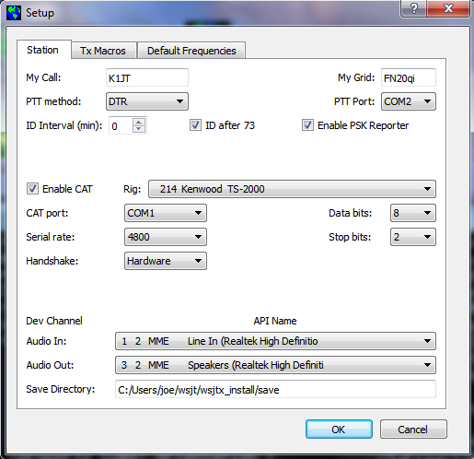

Fig. 1 — Station tab on the Setup screen.

- Select submode JT9-1 from the Mode menu and Normal from the Decode menu. On the Wide Graph window select JT9 Sync (rather than Current or Cumulative) for data display. Select tab 2 (just below the Erase button) to choose the alternative set of controls for generating and selecting messages to be transmitted. Then select File | Open, navigate to directory …\Save\Samples under your WSJT-X installation directory, and open the example file 130228_2158.wav. You should see something like the screen shots in Figure 2, next page. Note that two JT9 signals have been decoded: KF7JGF is calling CQ, and G4HSK is responding to a CQ from K1JT. These signals are visible on the waterfall near audio frequencies 1140 and 1238 Hz, respectively. At SNR = -25 dB, the signal from G4HSK is close to the minimum for reliable decoding. The strong, wide signal between about 1400 and 1800 Hz is some other data mode; the JT9 decoder will spend some time trying to make sense of it, and then will eventually ignore it. The KF7JGF signal is highlighted in green because he is calling CQ. The signal from G4HSK is highlighted in red because it is directed to “MyCall”, in this case K1JT.

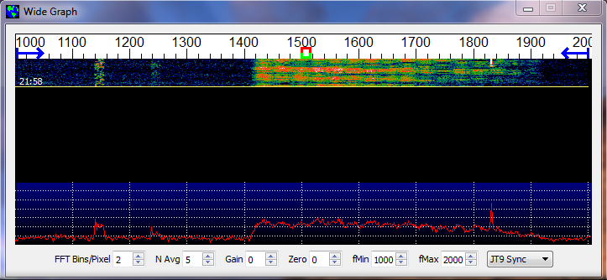

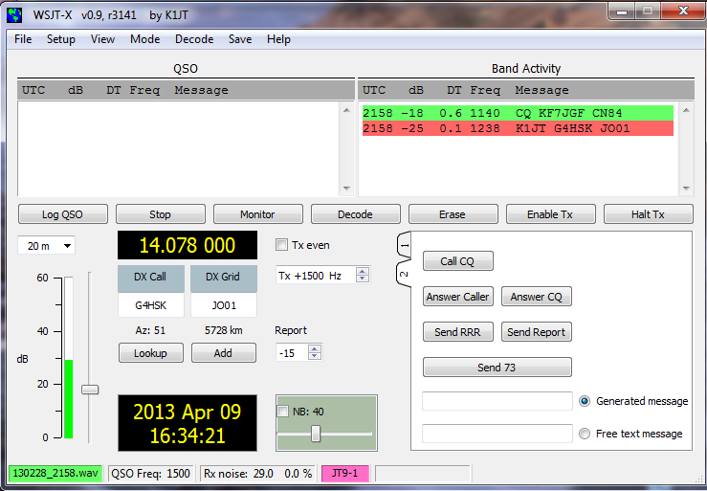

Fig. 2 — Wide Graph (upper) and Main window (lower) after opening the test file 130228_2158.wav.

- Notice on the waterfall frequency scale that the narrow-band Rx frequency is marked in green and the Tx frequency in red. The wideband decoding range is marked by blue arrows. The normal wideband range is 1000 – 2000 Hz, but you can move the limits using the fMin and fMax spinner controls.

- To get some feeling for controls you will use frequently when making QSOs, try clicking with the mouse on the decoded text lines and on the waterfall spectrum display. You should be able to confirm the following behavior:
  - Double-click on decode line highlighted in green — copy callsign and locator of station calling CQ to “DX Call” and “DX grid”; generate suitable messages for minimal QSO with this station; moce Rx (green) and Tx (red) frequency markers on waterfall scale to match frequency of station calling CQ.
  - Double-click on decode line highlighted in red — similar to (a) except Tx frequency is not moved.
  - Click on waterfall — move Rx frequency (green marker) to selected frequency.
  - CTRL-click on waterfall — move Rx and Tx frequencies.
  - Double-click on waterfall — move Rx frequency and decode there. Notice that the decoded text now appears in the “QSO” window.
  - CTRL-double-click — move Rx and Tx frequencies and decode there.

- Examine the user options presented on the Setup menu. You may want to select some of these for your normal operation.

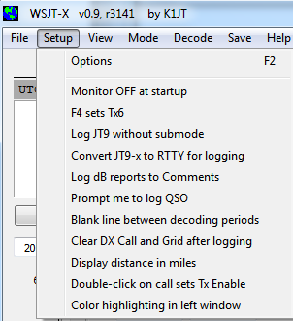

- Click the Monitor button to return to normal receive operation and set the background noise level to around 30 dB on the thermometer scale at lower left of the main screen. With the slider at mid-scale, the dB scale is calibrated relative to the least significant bit of a 16-bit A/D converter in the soundcard. This setting is not critical.

- You should now be ready to make QSOs with the JT9 modes in WSJT-X.

Hints for New Users
- AGC off (or turn RF gain down until AGC action is minimal).
- Set background noise level to about 30 dB on the WSJT-X meter. For best dynamic range, the slider to the right of the green-bar indicator should be near mid-scale when this is true.
- The waterfall frequency range always starts at 1000 Hz, which means that your on-the-air frequency range starts exactly 1 kHz above your dial frequency. The upper frequency limit depends on JT9 sub-mode, the setting of FFT bins/pixel, and the width of the waterfall graph. In normal use the recommended audio frequency range is 1000–2000 Hz for sub-modes JT9-1 and JT9-2, 1000–1300 Hz for JT9-5, 1000–1150 Hz for JT9-10, and 1000–1050 Hz for JT9-30.
- For best waterfall sensitivity, set N Avg ≥ 3.
- Double-click on a decoded message to copy the callsign and locator into DX Call and DX Grid. This will also generate appropriate standard messages, including signal report.
- You have three options for the 2D plot under the waterfall. Check Current to see the spectrum averaged over the most recent N Avg FFTs. Check Cumulative to see the spectrum averaged since start of the Rx interval. Check JT9 Sync to see the program’s first attempt at identifying a valid JT9 sync signal in the selected submode.
- WSJT-X requires that computer time information at transmitter and receiver should be accurate to within about ± 2 seconds. The recommended software for synchronization by internet is Meinberg NTP. See http://www.satsignal.eu/ntp/setup.html for installation instructions.

Bug Reports and Feature Requests
WSJT-X is still in an early stage of development, and user feedback is welcome. Send reports to k1jt@arrl.net.

The JT9 Protocol

JT9 is a mode designed for making QSOs at MF and LF. The mode uses essentially the same 72-bit structured messages as JT65. Error control coding (ECC) uses a strong convolutional code with constraint length K=32, rate r=1/2, and a zero tail, leading to an encoded message length of (72+31) × 2 = 206 information-carrying bits. Modulation is 9-FSK: 8 tones are used for data, one for synchronization. Sixteen symbol intervals are used for synchronization, so a transmission requires a total of 206 / 3 + 16 = 85 (rounded up) channel symbols. Symbol durations are approximately (TRperiod - 8) / 85, where TRperiod is the T/R sequence length in seconds. Exact symbol lengths are chosen so that nsps, the number of samples per symbol (at 12000 samples per second) is a number with no prime factor greater than 7. This choice makes for efficient FFTs. Tone spacing of the 9-FSK modulation is df = 1 / tsym = 12000 / nsps, equal to the keying rate. The total occupied bandwidth is 9 × df. The generated signal has continuous phase and constant amplitude, and there are no key clicks.

Parameters of five JT9 sub-modes are summarized in the following table, along with approximate S/N thresholds measured by simulation on an AWGN channel. Numbers following “JT9-” in the sub-mode names specify TRperiod in minutes.

Submode | nsps | Symbol Duration  (s) | Tone Spacing (Hz) | Signal Bandwidth (Hz) | S/N Threshold* (dB) | QSO Time (minutes)
JT9-1 | 6912 | 0.58 | 1.736 | 15.6 | -27 | 6
JT9-2 | 15360 | 1.28 | 0.781 | 7.0 | -30 | 12
JT9-5 | 40960 | 3.41 | 0.293 | 2.6 | -34 | 30
JT9-10 | 82944 | 6.91 | 0.145 | 1.3 | -37 | 60
JT9-30 | 252000 | 21.00 | 0.048 | 0.4 | -42 | 180

* Noise power measured in 2500 Hz bandwidth.

