WSJT-X Quick-Start Guide

WSJT-X is an experimental version of WSJT implementing JT9, a new mode designed especially for use on the MF and LFbands. JT9 shares many characteristics with the popular modesJT65 and JT4. All three are designed for making QSOs under extreme weak-signal conditions. They use nearly identical message structure and source encoding. JT65 is used for EME on the VHF/UHF bands, and for worldwide QRP communication at HF. JT4 is used mainly on the microwave bands. In contrast, JT9 is optimized for the 1.8 MHz, 472 kHz, and 137 kHz bands.

JT9 offers five choices for the duration of timed T/R sequences: submodes JT9-1, JT9-2, JT9-5, JT9-10, and JT9-30 use 1, 2, 5, 10, and 30 minutes,respectively. Submodes with longer transmissions trade reduced throughput for smaller bandwidth and increased sensitivity. The slowest submode, JT9-30, has total bandwidth 0.4 Hz and operates at signal-to-noise ratios as low as -40 dB measured in the standard 2.5 kHz reference bandwidth.

In addition to presenting a new operating mode with uniquely desirable characteristics, WSJT-X also serves as test vehicle for a new WSJT programming framework. The graphical user interface in earlier versions was written in the programming language Python and used the Tcl/Tk toolkit. For these tasks WSJT-X uses C++ and the Qt framework. Most users will hardly notice these differences, but the new scheme should make program maintenance on multiple platforms more straightforward. This initial experimental release incorporates only the new JT9 modes, but in time the other popular WSJT modes will be added.

This document assumes that you already have some familiarity with WSJT. If you do not, please read the WSJT User’s Guide first.

Installation and Setup
- WSJT-X can be downloaded from the WSJT Home Page at http://www.physics.princeton.edu/pulsar/K1JT/. Click on the WSJT link at the left margin and then on the appropriate download link for WSJT-X.
- Under Windows, execute the downloaded file and follow the installation instructions. Under Vista or Windows 7 be sure to install WSJT-X into its own directory (the suggested default is c:\wsjtx) rather than C:\Program Files\wsjtx.
- Start WSJT-X and Select Options from its Setup menu. Enter your callsign and locator. Select the PTT Port to be used for T/R control, or None if you if you will use VOX control (not recommended if you are running high power). Select suitable devices from the drop-down lists for Audio In and Audio Out. Click OK to dismiss the Options window, and click the Stop button on the main window to halt any data acquisition.
- Select submode JT9-1 from the Mode menu. Click on the Wide Graph window just under 1500 Hz on the audio frequency scale, and select JT9 Sync for data display.Then select File | Open, navigate to directory …\Save\Samples under your WSJT-X installation directory, and open the example file 000000_0000.wav. You should see something like the following screen shot:

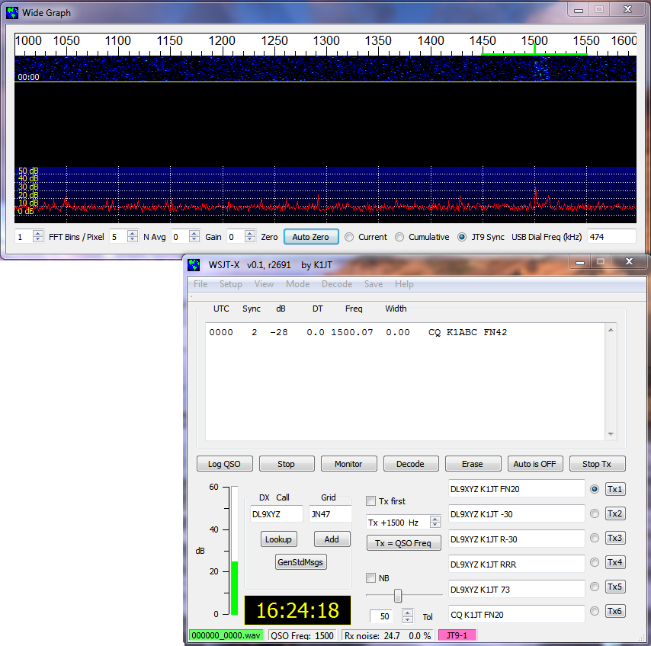

- If all is well and you are familiar with earlier versions of WSJT, you should now be able to use the JT9 modes in WSJT-X.

Be aware that the initial release of WSJT-X has some shortcuts and limitations. A number of reported parameters have not been properly calibrated, and the JT9 decoder is not fully optimized. Many improvements are still to be made, and user feedback is welcome!
Hints for New Users
- AGC off (or turn RF gain down until AGC action is minimal).
- Set background noise level to 20 – 30 dB on the WSJT-X meter.
- The waterfall frequency range always starts at 1000 Hz. This means that your on-the-air frequency range starts exactly 1 kHz above your dial frequency. The upper frequency limit depends on JT9 submode, the setting of FFT bins/pixel, and the width of the waterfall graph.
- For most users the recommended audio frequency range is 1000–2000 Hz for submodes JT9-1 and JT9-2, 1000–1300 Hz for JT9-5, 1000–1150 Hz for JT9-10, and 1000–1050 Hz for JT9-30.
- For best waterfall sensitivity, set FFT bins/pixel = 1 and N Avg ≥ 3.
- Click on waterfall to set QSO Frequency. Double-click to set QSO Frequency and start the decoder.
- Double-click on a decoded callsign to copy it into DX Call and generate appropriate standard messages, including signal report.
- You have three options for the 2-d plot under the waterfall . Check Current to see the average spectrum over the most recent number N Avg of FFTs. Check Cumulative to see the spectrum averaged since start of the Rx interval. Check JT9 Sync to see the program’s best attempt at identifying the lowest-frequency tone of a valid JT9 signal in the selected submode.

The JT9 Protocol

JT9 is a mode designed for making QSOs at MF and LF. The mode uses essentially the same 72-bit structured messages as JT65. Error control coding(ECC) uses a strong convolutional code with constraint length K=32,rate r=1/2, and a zero tail, leading to an encoded message length of (72+31) × 2 = 206 information-carrying bits. Modulation is 9-FSK: 8tones for data, one for synchronization. Sixteen symbol intervals areused for synchronization, so a transmission requires a total of 207/3+ 16 = 85 channel symbols. Symbol durations are approximately(TRperiod-8)/85, where TRperiod is the T/R sequence length in seconds.Exact symbol lengths are chosen so that nsps, the number of samplesper symbol (at 12000 samples per second) is a number with no primefactor greater than 7. This choice makes for efficient FFTs. Tonespacing of the 9-FSK modulation is df=1/tsym=12000/nsps, equal to thekeying rate. The total occupied bandwidth is 9*df. The generatedsignal has continuous phase and constant amplitude, and there are no key clicks.

Parameters of five JT9 sub-modes are summarized in the followingtable, along with approximate S/N thresholds measured by simulation on an AWGN channel. Numbers following “JT9-” in the sub-mode names specify TRperiod in minutes.

Submode | nsps | Symbol Duration  (s) | Tone Spacing (Hz) | Signal Bandwidth (Hz) | S/N Threshold* (dB) | QSO Time (minutes)
JT9-1 | 6912 | 0.58 | 1.736 | 15.6 | -27 | 6
JT9-2 | 15360 | 1.28 | 0.781 | 7.0 | -30 | 12
JT9-5 | 40960 | 3.41 | 0.293 | 2.6 | -34 | 30
JT9-10 | 82944 | 6.91 | 0.145 | 1.3 | -37 | 60
JT9-30 | 252000 | 21.00 | 0.048 | 0.4 | -42 | 180

* Noise power measured in 2500 Hz bandwidth.

