WSJT-X User’s Guide

Joe Taylor, K1JT

Copyright © 2013
April 26, 2013

Contents
Introduction 3
System Requirements 3
Quick-Start Installation and JT9 Setup 4
Operating Hints 7
Menus 8
Keyboard Shortcuts 10
Special Mouse Commands 11
Additional Features and Options 11
Appendix A: Installed and Generated Files 11
Appendix B: The JT9 Protocol 13
Appendix C: Source Code 13

Introduction
WSJT-X is a computer program designed for amateur radio communication using low power and/or weak signals. The first four letters in the program name stand for “Weak Signal communication by K1JT”, and the “-X” suffix indicates that WSJT-X is an experimental branch of program WSJT.
Version 1.0 of WSJT-X offers the new mode JT9, designed especially for use on the LF, MF, and HF bands. JT9 shares many characteristics with the modes JT65 and JT4 made popular in WSJT. All three are designed for making minimal QSOs under extreme weak-signal conditions. They use nearly identical message structure and source encoding. JT65 is used for EME on the VHF/UHF bands and for worldwide QRP communication at HF, while JT4 is used mainly on the microwave bands. In contrast, JT9 is optimized for HF and lower frequencies. JT9 is about 2 dB more sensitive than JT65A while using less than 10% of the bandwidth.
JT9 offers five choices for the duration of timed T/R sequences: submodes JT9-1, JT9-2, JT9-5, JT9-10, and JT9-30 use 1, 2, 5, 10, and 30 minutes, respectively. Even with JT9-1 a minimal QSO takes 5 or 6 minutes, so for obvious reasons JT9-1 is the preferred submode under most circumstances. The sub-modes with longer transmissions trade reduced throughput for smaller bandwidth and increased sensitivity. The slowest sub-mode, JT9-30, has total bandwidth 0.4 Hz and operates at signal-to-noise ratios as low as –40 dB measured in the standard 2.5 kHz reference bandwidth. It requires very stable oscillators in both transmitter and receiver. JT9-1 is the recommended submode unless you really need the additional sensitivity of a slower mode.

System Requirements
- SSB transceiver and antenna
- Computer running Windows XP or later. (WSJT-X also runs under Linux and OS X, but we do not yet provide click-to-install packages for these operating systems. See Appendix B.)
- 1.5 GHz or faster CPU and 512 MB of available RAM
- Monitor with at least 800 x 600 resolution (more is better)
- Sound card supported by your operating system
- Computer-to-radio interface using a serial port to key your PTT line, or CAT control.
- Audio connections between transceiver and sound card
- A means for synchronizing your computer clock to UTC. I recommend Meinberg NTP, see http://www.satsignal.eu/ntp/setup.html for installation instructions.

Quick-Start Installation and JT9 Setup
- WSJT-X can be downloaded from the WSJT Home Page at http://www.physics.princeton.edu/pulsar/K1JT/. Click on the WSJT link at the left margin and then on the appropriate download link for WSJT-X.
- Under Windows, execute the downloaded file and follow the installation instructions. Install WSJT-X into its own directory (the suggested default is C:\WSJTX) rather than the conventional C:\Program Files\WSJTX.
- Start WSJT-X and Select Configuration from its Setup menu. Enter your callsign and Maidenhead grid locator as shown in the screen shot on the next page, and set the remaining parameters as required for your station. Try clicking the Test CAT Control and Test PTT buttons to see that you have established the desired control of station functions. Then click OK to dismiss the Configuration window.
- If necessary, click the Stop button on the main window to halt any data acquisition. Select submode JT9-1 from the Mode menu and Normal from the Decode menu. On the Wide Graph window select JT9 Sync (rather than Current or Cumulative) for data display. Select Tab 2 (just below the Erase button on the main window) to choose the alternative set of controls for generating and selecting messages to be transmitted. Then select File | Open, navigate to directory …\Save\Samples under your WSJT-X installation directory, and open the example file 130426_0027.wav. You should see something like the screen shots below and on the next page.
Notice the green, red, and blue markers on the waterfall frequency scale. Decoding in JT9 mode takes place at the end of a receive sequence and is organized in two stages. The first decodes are at the selected Rx frequency, indicated by the green marker. These decoding results appear in the both the left (“QSO Frequency”) and right (“Band Activity”) text windows. The decoder then finds and decodes all JT9 signals between the blue markers at frequencies f Min and f Max. The normal wideband decoding range is 1000 – 2000 Hz, but you can move the limits using the f Min and f Max spinner controls. The red marker indicates the Tx frequency.

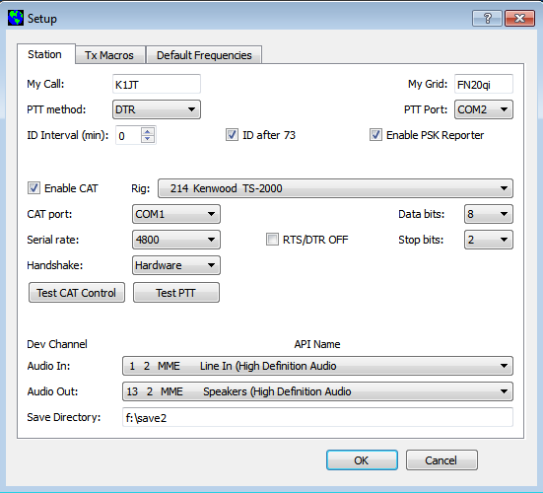

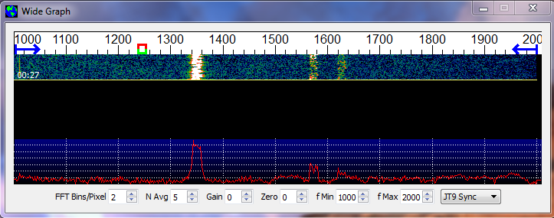
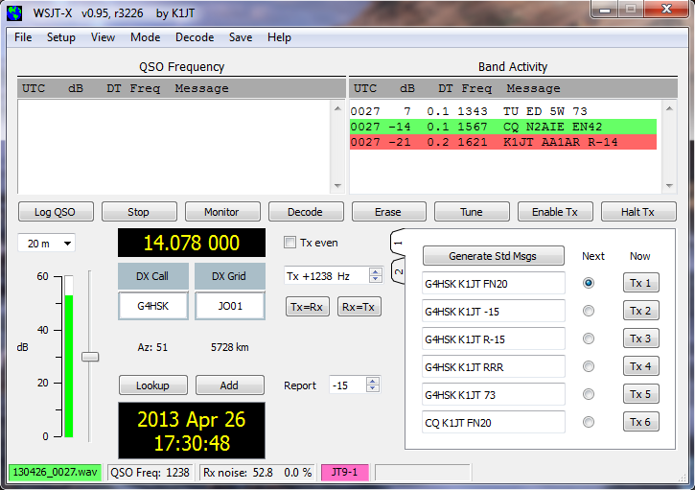
- Note that three JT9 signals have been decoded: someone has ended a QSO by sending “TU ED 5W 73”, NA2AIE is calling CQ, and AA1AR is sending a signal report to K1JT. These signals are visible on the waterfall near audio frequencies 1343, 1567, and 1621 Hz, respectively. The N2AIE signal is highlighted in green because he is calling CQ. The signal from AA1AR is highlighted in red because it is directed to the callsign entered on the Setup | Configuration screen as “MyCall”, in this case K1JT.
- To gain some feeling for the controls you will use for making QSOs, try clicking with the mouse on the decoded text lines and on the waterfall spectrum display. You should be able to confirm the following behavior:
  - Double-click on the decoded line highlighted in green. This action copies callsign and locator of a station calling CQ to the “DX Call” and “DX grid” entry fields, and then generates suitable messages for a minimal QSO. Rx and Tx frequency markers will be moved to the CQing station’s frequency.
  - Double-click on the decoded line highlighted in red. Results will be similar to (a), except the Tx frequency (red marker) is not moved.
  - Clicking on the waterfall moves the Rx frequency (green marker) to the selected frequency.
  - CTRL-click on waterfall moves both Rx and Tx frequencies.
  - Double-click on waterfall moves the Rx frequency and causes a narrow-band decode there. Decoded text appears in the left (“QSO”) window.
  - CTRL-double-click moves both Rx and Tx frequencies and decodes there.
  - Clicking Erase clears the QSO window. Double-clicking Erase clears both text windows.
- Click the Monitor button to return to normal receive operation. Using the receiver gain control(s) and/or the Windows mixer controls, set the background noise level to around 30 dB on the thermometer scale at lower left of the WSJT-X main screen. If necessary you can also use the slider next to the thermometer scale, but the overall dynamic range will be best with the slider at mid-scale. When this is true, the dB scale is calibrated relative to the least significant bit of 16-bit samples from the soundcard.
- You should now be ready to make QSOs with the JT9 modes in WSJT-X.

Operating Hints
By longstanding tradition, a minimal valid QSO requires the exchange of callsigns, a signal report or some other information, and acknowledgments. WSJT-X is designed to facilitate making such minimal QSOs with very weak signals, and the process can be made easier if you follow standard operating practices. The recommended basic QSO goes something like this:
1. CQ K1ABC FN42
2. K1ABC G0XYZ IO91
3. G0XYZ K1ABC -19
4. K1ABC G0XYZ R-22
5. G0XYZ K1ABC RRR
6. K1ABC G0XYZ 73

These standard structured messages consist of two callsigns followed by a grid locator, a signal report, or the acknowledgement “RRR” or sign-off “73”. As described in Appendix X, such messages are compressed and handled in an extremely efficient manner. Many users will add some friendly chit-chat as a final transmission, for example sending for transmission #6 the message “TNX JOE 73 GL”. Free-text messages like this are limited to 13 characters. It should be obvious that JT9 is not a mode suitable for extensive conversations or rag-chewing.

Menus
Menus at the top of the WSJT-X main window offer a number of options for program configuration and operation. Most menu items should be self-explanatory.
File
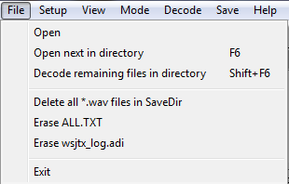
Setup
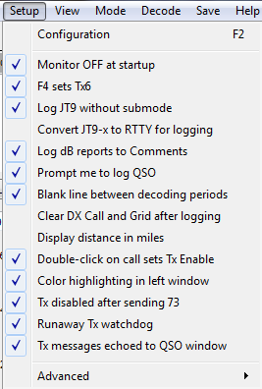

View
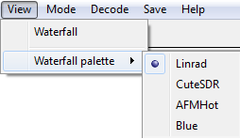
Mode
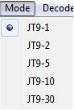
Decode
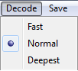
Save
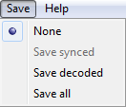

Help
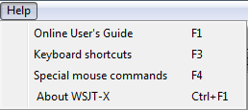

Keyboard Shortcuts
F1 Online User's Guide
F2 Open configuration window
F3 Display keyboard shortcuts
F4 Display special mouse commands
Alt+F4 Exit program
F6 Open next in directory
F11 Move Rx frequency down 1 Hz
Ctrl+F11 Move Rx and Tx frequencies down 1 Hz
F12 Move Rx frequency up 1 Hz
Ctrl+F12 Move Rx and Tx frequencies up 1 Hz
Shift+F6 Decode remaining files in directory
Ctrl+F1 About WSJT-X
Alt+D Decode again at QSO frequency
Shift+D Full decode (both windows)
Alt+E Erase()
Ctrl+F Edit the free text message box
Alt+G Generate standard messages
Alt+H Halt Tx()
Ctrl+L Lookup callsign in database, generate standard messages
Alt M Monitor()
Alt+N Enable Tx()
Alt+Q Log QSO()
Alt+S Stop()
Alt+T Tune
Alt+V Save the most recently completed *.wav file

Special Mouse Commands
Mouse-click on | Action
Waterfall | Set Rx frequency  Double-click to set Rx frequency and decode there  Ctrl-click to set Rx and Tx frequencies and decode
Decoded text | Double-click to copy second callsign to Dx Call and locator to Dx Grid; change Rx and Tx frequencies to decoded signal's frequency; generate standard messages. If first callsign is your own, Tx frequency is changed only if Ctrl is held down when double-clicking.
Erase button | Click to erase QSO window  Double-click to erase QSO and Band Activity windows
Tx5 Entry | Right-click to select a macro message

Additional Features and Options
The

Appendix A: Installed and Generated Files
After installing WSJT-X as described in steps 1 and 2 on page 4, the following files will be present in the installation directory:
afmhot.dat Data for AFMHot palette
blue.dat Data for Blue palette
CALL3.TXT Callsign database
jt9.exe Executable for JT9 decoder
mouse_commands.txt Special mouse commands
save Directory for saved *.wav files
shortcuts.txt Keyboard shortcuts
unins000.dat
unins000.exe Executable for uninstalling WSJT-X
wsjt.ico WSJT icon
wsjtx.exe Executable for WSJT-X

In addition, the following *.dll support files will have been installed in your WSJT-X directory.
hamlib-alinco.dll Hamlib libraries
hamlib-amsat.dll ...
hamlib-flexradio.dll
hamlib-icom.dll
hamlib-jrc.dll
hamlib-kachina.dll
hamlib-kenwood.dll
hamlib-kit.dll
hamlib-tapr.dll
hamlib-tentec.dll
hamlib-winradio.dll
hamlib-yaesu.dll
libfftw3f-3.dll Optimized FFT library
libgcc_s_dw2-1.dll gcc runtime
libhamlib-2.dll
libstdc++-6.dll standard C function library
libusb0.dll USB interface functions
mingwm10.dll MinGW library
palir-02.dll Linrad functions
PSKReporter.dll Library for PSK reporter
QtCore4.dll Qt core library
QtGui4.dll Qt GUI library
QtNetwork4.dll ...
QtSvg4.dll
qwt.dll Qwt library

You might be curious about additional files that appear in the MWSJT-X installation directory after using the program for a while. These include:
kvasd.dat Data for the Koetter-Vardy decoder
ALL.TXT Log of all received and transmitted messages
decoded.txt Decoded text from the most recent Rx interval
timer.out Diagnostic information for decoder optimization
wsjtx.ini Saved configuration parameters
wsjtx_status.txt Information sent to companion program JT-Alert-X
map65_tx.log Log of all transmitted messages
prefixes.txt List of available add-on DXCC prefixes
timer.out Profile showing times in decoder routines
tmp26.txt Intermediate file used by decoder

Appendix B: The JT9 Protocol
JT9 is a mode designed for making QSOs at MF and LF. The mode uses essentially the same 72-bit structured messages as JT65. Error control coding (ECC) uses a strong convolutional code with constraint length K=32, rate r=1/2, and a zero tail, leading to an encoded message length of (72+31) × 2 = 206 information-carrying bits. Modulation is 9-FSK: 8 tones are used for data, one for synchronization. Sixteen symbol intervals are used for synchronization, so a transmission requires a total of 206 / 3 + 16 = 85 (rounded up) channel symbols. Symbol durations are approximately (TRperiod - 8) / 85, where TRperiod is the T/R sequence length in seconds. Exact symbol lengths are chosen so that nsps, the number of samples per symbol (at 12000 samples per second) is a number with no prime factor greater than 7. This choice makes for efficient FFTs. Tone spacing of the 9-FSK modulation is df = 1 / tsym = 12000 / nsps, equal to the keying rate. The total occupied bandwidth is 9 × df. The generated signal has continuous phase and constant amplitude, and there are no key clicks.

Parameters of five JT9 sub-modes are summarized in the following table, along with approximate S/N thresholds measured by simulation on an AWGN channel. Numbers following “JT9-” in the sub-mode names specify TRperiod in minutes.

Submode | nsps | Symbol Duration  (s) | Tone Spacing (Hz) | Signal Bandwidth (Hz) | S/N Threshold* (dB) | QSO Time (minutes)
JT9-1 | 6912 | 0.58 | 1.736 | 15.6 | -27 | 6
JT9-2 | 15360 | 1.28 | 0.781 | 7.0 | -30 | 12
JT9-5 | 40960 | 3.41 | 0.293 | 2.6 | -34 | 30
JT9-10 | 82944 | 6.91 | 0.145 | 1.3 | -37 | 60
JT9-30 | 252000 | 21.00 | 0.048 | 0.4 | -42 | 180

* Noise power measured in 2500 Hz bandwidth.

Appendix C: Source Code
WSJT-X is an open-source program released under the GNU General Public License. Source code is available from the public repository at http://developer.berlios.de/projects/wsjt/. To compile the program you will need to install open source packages for Subversion, QtSDK, qwt, g++, g95 or gfortran, portaudio, fftw3, and hamlib. For compiling in Windows I recommend installing the MinGW package.
The full source code for WSJT-X can be downloaded by using the command
svn co svn://svn.berlios.de/wsjt/branches/wsjtx

